COURSEWORK 1
Aaron Patrick Monte
Student Number: 20059926

1.1 Er diagram
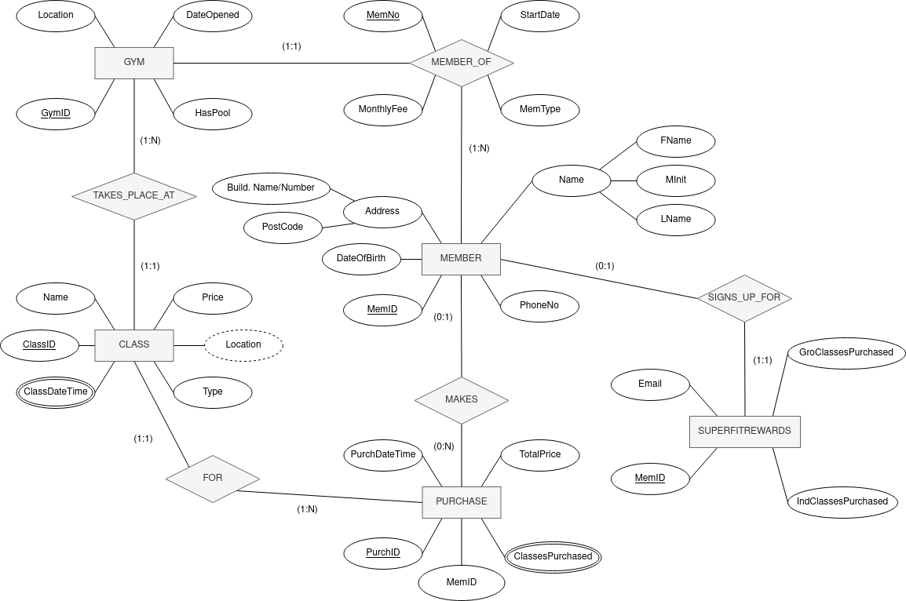

1.2 Cardinalities and Assumptions

Superfitrewards
- A MEMBER can SIGN_UP_FOR SUPERFITREWARDS only once.
  - The handling of the free classes offered by SUPERFITREWARDS will be handled by an external program, thus it does not have a relation – it only stores the necessary information for handling the free classes.

Member
- A MEMBER can be a MEMBER_OF many GYMs, but can only have one membership for a particular gym at a time.

Purchase
- A MEMBER can MAKE a PURCHASE, which can be FOR multiple CLASSes. It will be recorded
  - The member’s information can be accessed from the PURCHASE entity as it stores the MEMBER’s MemID, and can be cross referenced.
  - This attribute does not need to be filled, to allow non-members to purchase classes too.

Class
- The same CLASS takes can take place many GYMs at different ClassDateTimes.
- The CLASS Name identifies what kind of class it is, therefore multiple instances of the same class can occur, but under a different ClassID.
- The CLASS LOCATION is derived by where it TAKES_PLACE_AT. Therefore, it is also a multivalued attribute
- A CLASS’s sessions is stored under a single CLASS instance, e.g.:
ClassID | Name | Type | Price | ClassDateTime | Location
13120 | 0 | 0 | 0 | 01/01/2021 18:00:00  08/01/2021 16:00:00  15/01/2021 18:00:00  22/01/2021 16:00:00 | P.E.I  P.E.I  P.E.I  Toronto

1.3 Relational schema
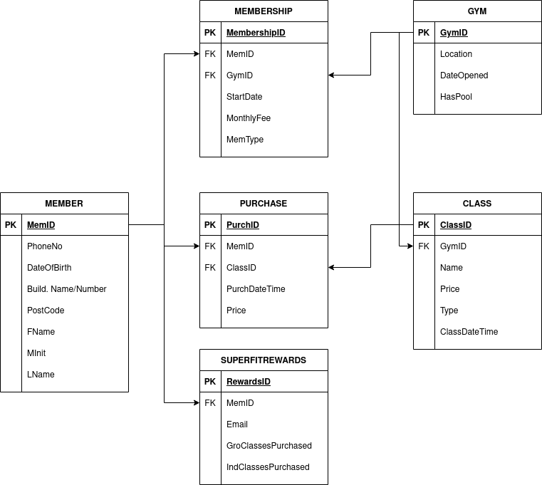

1.4 constraints

Primary/Foreign keys
All primary and foreign keys have been identified in the schema, with PK indicating the primary key, and FK indicating the foreign key.

Domain constraints

MEMBER
CREATE TABLE MEMBER (
MemID INTEGER NOT NULL,
PhoneNo INTEGER NOT NULL,
DateOfBirth DATE NOT NULL,
Build.Name/Number VARCHAR(35) NOT NULL,
PostCode VARCHAR(8) NOT NULL,
FName VARCHAR(50) NOT NULL,
MInit CHAR(1),
LName VARCHAR(50) NOT NULL,
PRIMARY KEY (MemID)
);

- Not everyone has a middle name, therefore MInit can be null.
- The VARCHAR lengths may need to be extended if there exists a name longer than what the database intends to store.

Membership
CREATE DOMAIN MONEY AS DECIMAL(4,2) CHECK (VALUE > 0);

CREATE TABLE MEMBERSHIP (
MembershipID INTEGER NOT NULL,
MemID INTEGER NOT NULL,
GymID INTEGER NOT NULL,
StartDate DATE NOT NULL,
MonthlyFee MONEY NOT NULL,
MemType VARCHAR(8) NOT NULL,
PRIMARY KEY (MembershipID)
FOREIGN KEY (MemID) REFERENCES MEMBER(MemID),
FOREIGN KEY (GymID) REFERENCES GYM(GymID)
);

- The MONEY domain might be used by other relations, e.g. in PURCHASE.

Gym
CREATE TABLE GYM (
GymID INTEGER NOT NULL,
Location VARCHAR(35) NOT NULL,
DateOpened DATE NOT NULL,
HasPool BOOLEAN NOT NULL,
PRIMARY KEY (GymID)
);

Semantic integrity constraints
- MemType needs to be either ‘GymOnly’, ‘SwimOnly’, or ‘Gym&Swim’, nothing else, as these are the types of memberships Fitness4All offers.
- The domain MONEY must be > 0. You can not purchase something with a negative value.
- ‘SwimOnly’ and ‘Gym&Swim’ are only available if GYM(HasPool) is true. This is because the gym will not offer these memberships if a pool is not available in the facility.

